**Assignment-1**

**Twitter Data Sentiment Analysis**

**Basic Initial Steps:**

1. Starting hive :

$DEV1/scripts/training_setup_dev1.sh

hive

1. Loading Dictionary.txt file into hive:

CREATE TABLE dictionary_lk0177(word string, rating int)

row format delimited

fields terminated by '\t';

LOAD DATA LOCAL INPATH 'Desktop/Dictionary.txt' INTO TABLE dictionary_lk0177;

1. Loading JSON file into hive:

First whole file is loaded into twitter_json table as string and then parsed using **get_json_object**

CREATE TABLE twitter_json ( json string );

LOAD DATA LOCAL INPATH 'Desktop/Twitter.json' INTO TABLE twitter_json;

CREATE TABLE twitter_lk0177 as

select get_json_object(twitter_json.json, '$.retweet_count') as retweet_count,

unix_timestamp(get_json_object(twitter_json.json, "$.created_at"),

"EEE MMM d HH:mm:ss Z yyyy") as created_at,

get_json_object(twitter_json.json, '$.text') as text,

get_json_object(twitter_json.json, '$.id') as id,

get_json_object(twitter_json.json, '$.source') as source,

get_json_object(twitter_json.json, '$.in_reply_to_screen_name') as in_reply_to_screen_name,

get_json_object(twitter_json.json, '$.user.location') as location,

get_json_object(twitter_json.json, '$.user.id') as u_id,

get_json_object(twitter_json.json, '$.user.id_str') as id_str,

get_json_object(twitter_json.json, '$.user.name') as name,

get_json_object(twitter_json.json, '$.user.screen_name') as screen_name,

get_json_object(twitter_json.json, '$.user.geo_enabled') as geo_enabled,

get_json_object(twitter_json.json, '$.user.lang') as lang,

get_json_object(twitter_json.json, '$.user.protected') as protected,

get_json_object(twitter_json.json, '$.user.verified') as verified,

get_json_object(twitter_json.json, '$.user.followers_count') as followers_count,

get_json_object(twitter_json.json, '$.user.friends_count') as friends_count,

get_json_object(twitter_json.json, '$.user.listed_count') as listed_count,

get_json_object(twitter_json.json, '$.user.favourites_count') as favourites_count,

get_json_object(twitter_json.json, '$.user.statuses_count') as statuses_count,

get_json_object(twitter_json.json,$.user.profile_background_color') as

profile_background_color

get_json_object(twitter_json.json, '$.contributors') as contributors,

get_json_object(twitter_json.json, '$.is_quote_status') as is_quote_status,

get_json_object(twitter_json.json,'$.entities.user_mentions.screen_name')as

user_mention_screen_name,

get_json_object(twitter_json.json, '$.entities.user_mentions.name') as user_mention_name,

get_json_object(twitter_json.json, '$.entities.user_mentions.id') as user_mention_id

from twitter_json;

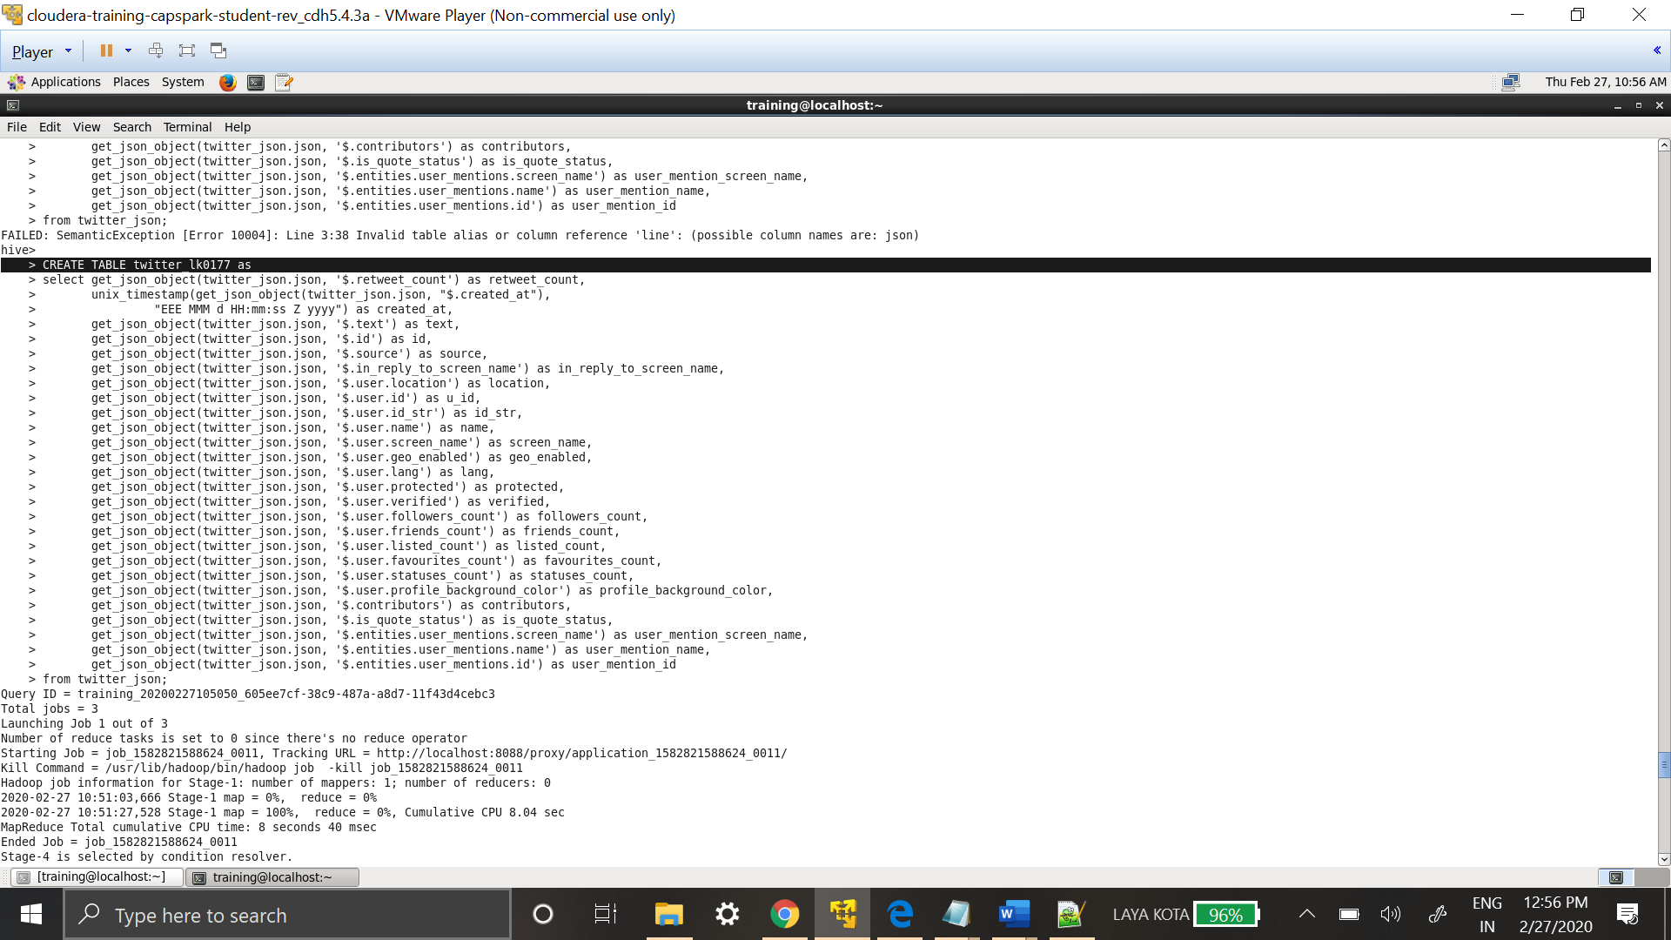

In **twitter_lk0177** table, data is stored as string in order to convert **created_at** column into required date column **unix_timestamp**  is used which will store column values as BIGINT, this step will help in further analysis.

**2. Using the files provided, answer the following:**

**a. What were the hashtags used in the file, and how many times each hashtag was used?**

**(10 points)**

Hashtags are in between the text in **text** column, **split** function is used to extract hashtags and **hashtag_lk0177** table is created to store the extracted hashtags.

CREATE TABLE hashtag_lk0177 as

select hashtag from twitter_lk0177

LATERAL VIEW explode(split(text,' ')) text_tweet as hashtag

where hashtag like '#%';

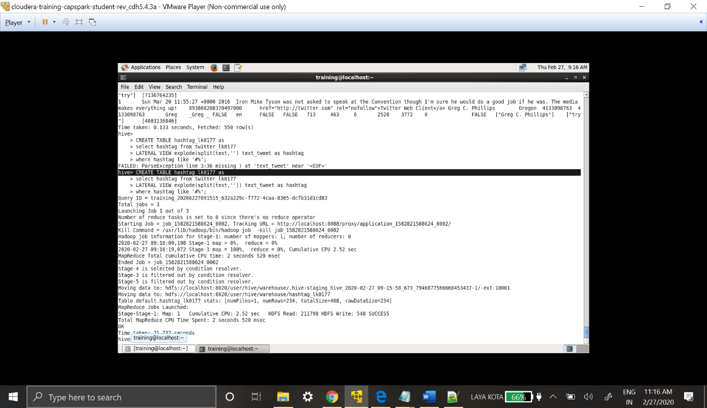

Select * from hashtag_lk0177;

Query is used to validate the table.

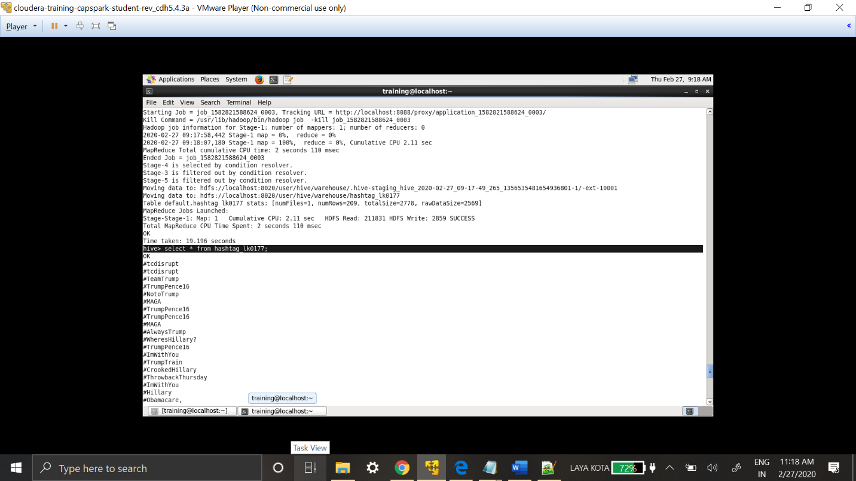

The second part of the question is count of hashtags, in order to obtain that **hashtag_count_lk0177** table is created to store hashtags and their count.

CREATE TABLE hashtag_count_lk0177 as

select hashtag, count(hashtag) as hashtag_count from hashtag_lk0177

GROUP BY hashtag

ORDER BY hashtag_count;

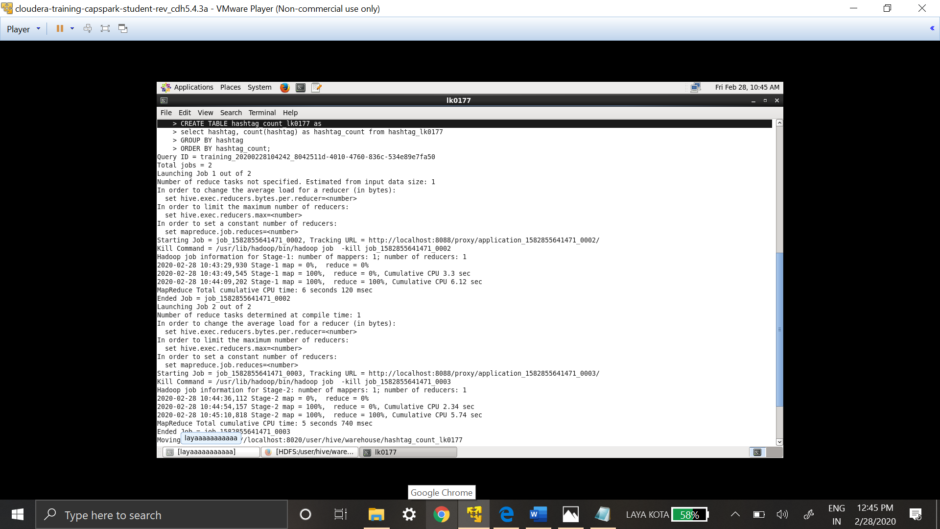

Select * from hashtag_count_lk0177 ORDER BY hashtag_count DESC;

Query is used to validate table creation. Hashtag_count_lk0177 table has all the hashtags and its counts.

During the table creating ORDER BY hashtag_count DESC; can be used to print the results in descending order instead of using it during select statement.

Most commonly used hashtags are:

#ImWithYou – 23

#MAGA - 18

#TrumpPence – 16

#CrookedHillary – 16

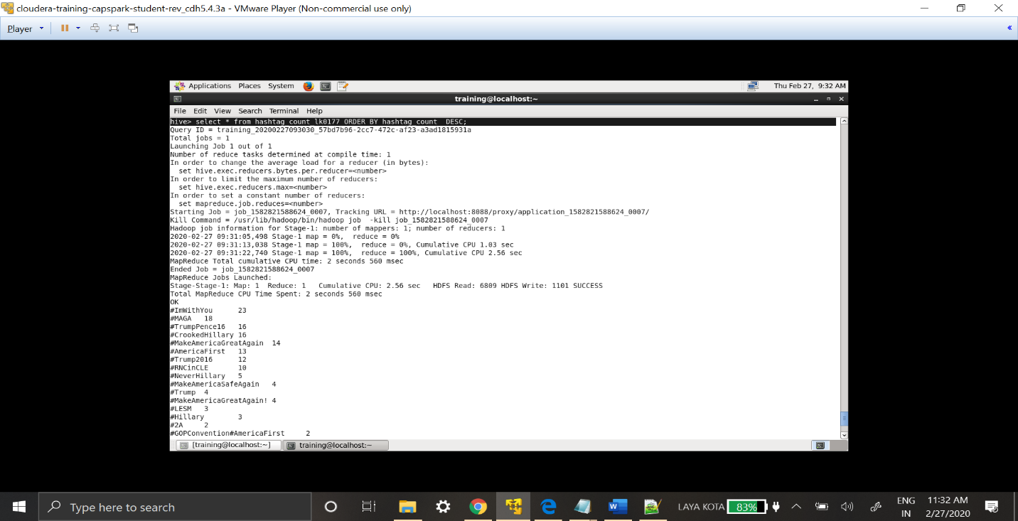

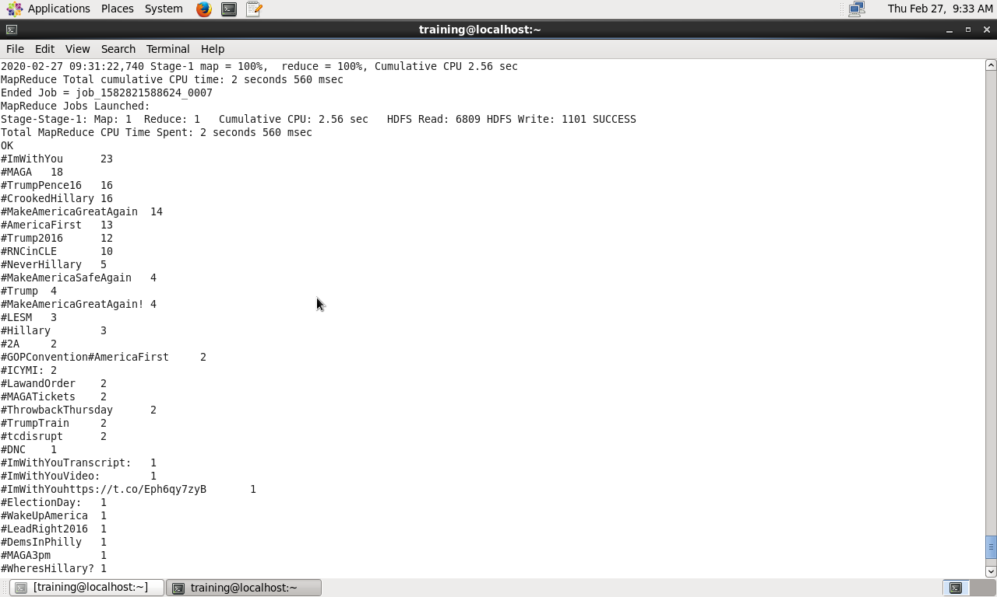

**b. Identify the most trending hashtag by the day. How many times the most trending hashtag was tweeted? (10 points)**

**[Note: day should be in the format ‘yyyy-mm-dd’]**

The approach to achieve solution to above question is to first convert the date into mentioned

‘yyyy-MM-dd’ format by using **from_unixtime** function and store id, name, text and data in one table. Next using **split** function to extract hashtags from text column.

CREATE TABLE date_lk0177 as

select id, name as user_name, text, from_unixtime(created_at,'yyyy-MM-dd') as date

from twitter_lk0177;

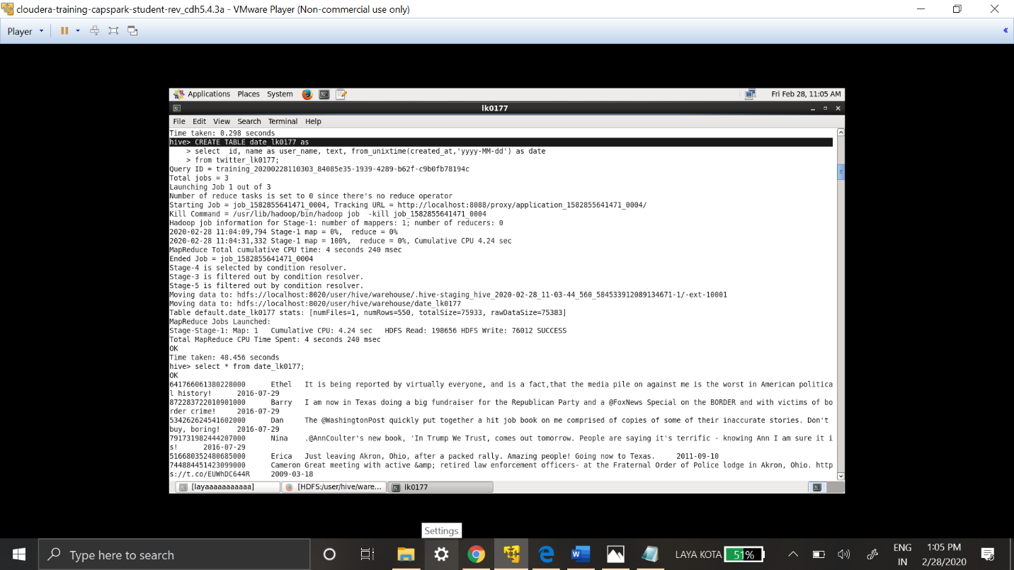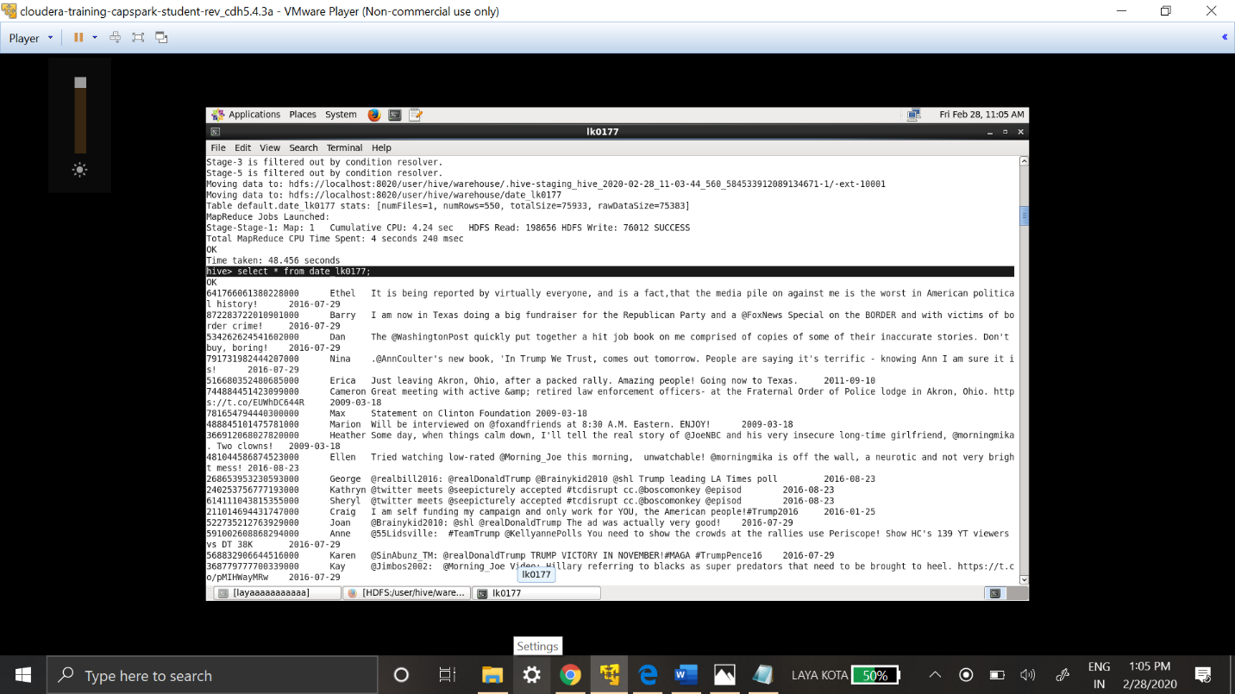

Select * from date_lk0177; is used to validate table creation.

**Creating a table with hashtags and date:**

Here two columns are used date column from date_lk0177 table and text is split using split functions to get only hashtags from text.

CREATE TABLE hashtag_date_lk0177 as

select hashtag, date from date_lk0177

LATERAL VIEW explode(split(text,' ')) text_tweet as hashtag

where hashtag like '#%';

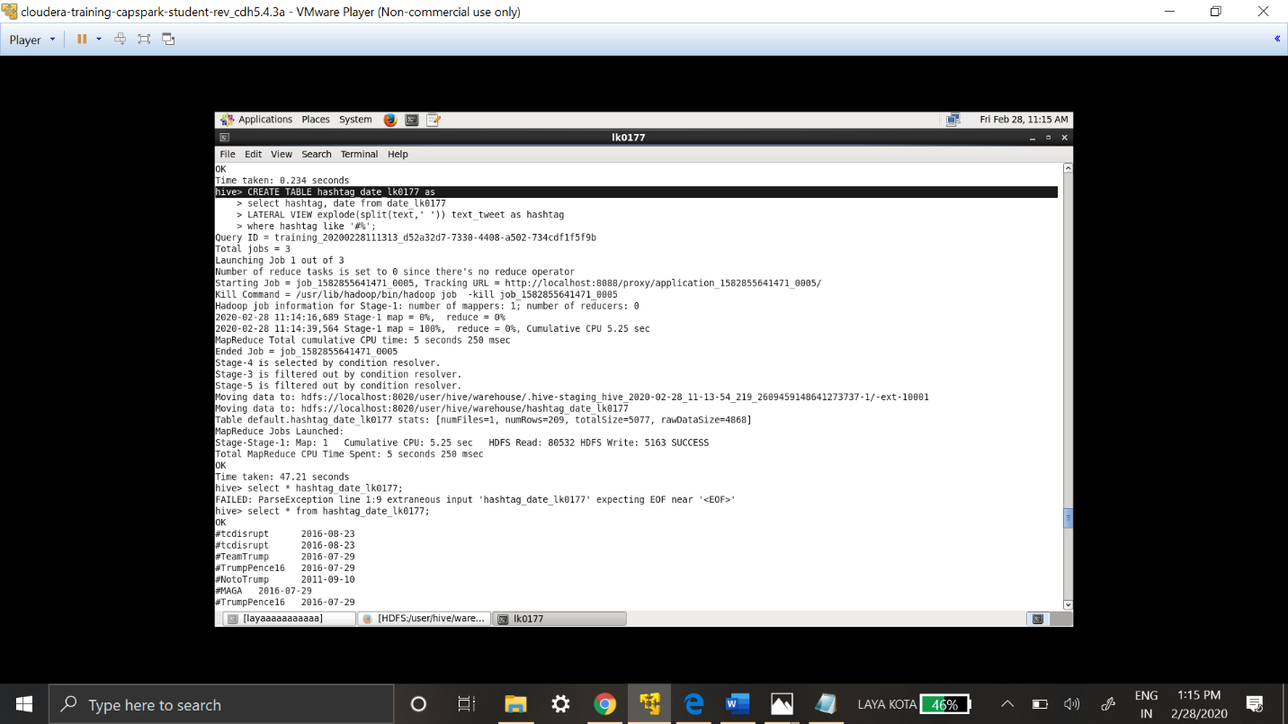

Select * from hashtag_date_lk0177;

This query is used to validate the table creation

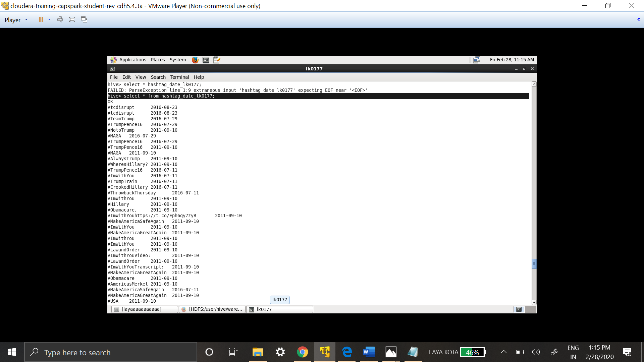

**Creation of table which has trending hashtags by date :**

CREATE TABLE trending_hashtag_byday_lk0177 as

select date, hashtag,count(hashtag) as hashtag_count from hashtag_date_lk0177

GROUP BY date, hashtag

ORDER BY hashtag_count DESC;

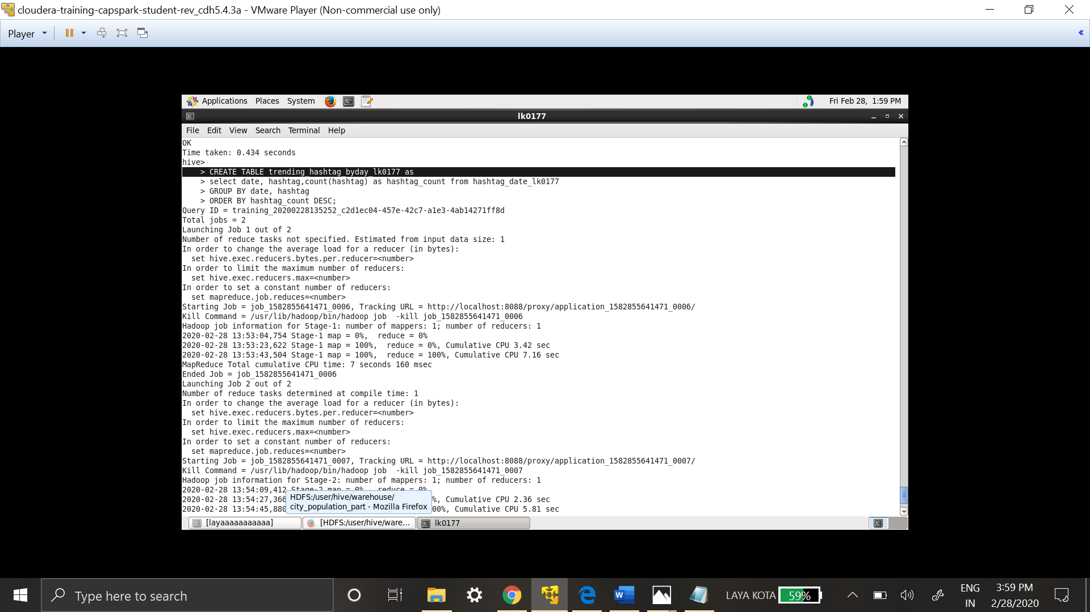

In order to get the most trending hashtag by date :

Select * from trending_hashtag_byday_lk0177;

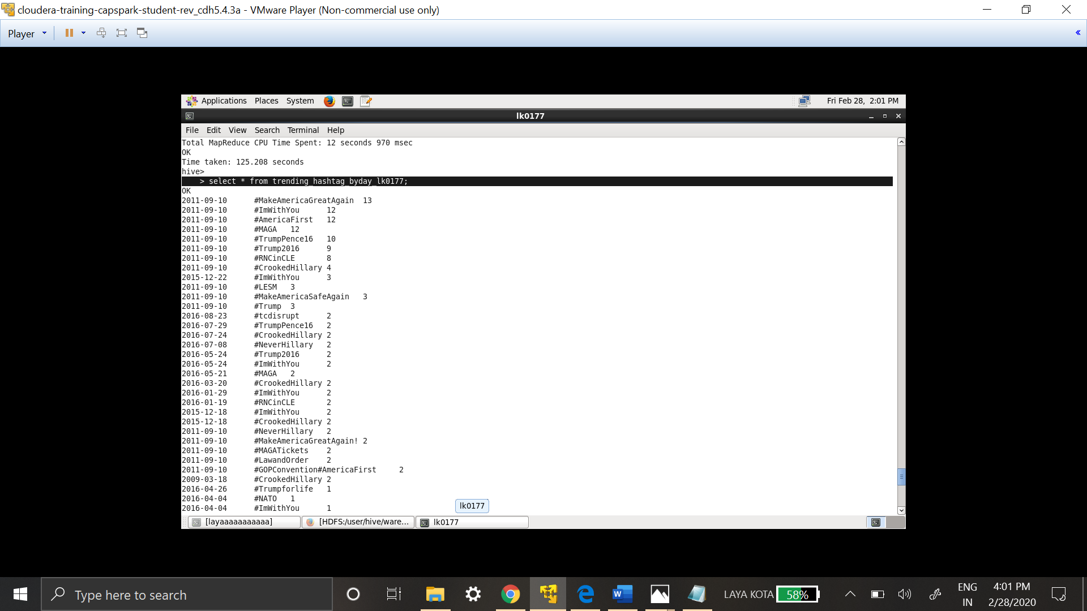

Most trending hashtags are # MakeAmericaGreatAgain, #ImWithYou, #MAGA, #AmericaFirst.

**c. Determine the score for each tweet that was posted? Identify whether the tweet had a positive or negative sentiment? Use the dictionary.txt file for determining the score. Note: Include the date (’yyyy-mm-dd’), tweet_id, user_name, and the score in the resulting query. (20 points)**

Approach to achieve above sentiment analysis, its required:

1. To have a table with all the required columns of twitter_lk0177.
2. To create join between twitter table and dictionary, matching all the words in dictionary with text in tweets.
3. Find the rating of all the matched words and provide sentiment analysis results.

**Creation of table with all the required columns from twitter data:**

Date table created earlier is used here. It has all the required columns and now text data is split into words in order to compare them with dictionary words.

CREATE TABLE split_text_lk0177 as

select id as tweet_id, user_name, tweet_words, date from date_lk0177

LATERAL VIEW explode(split(text,' ')) text_tweet as tweet_words;

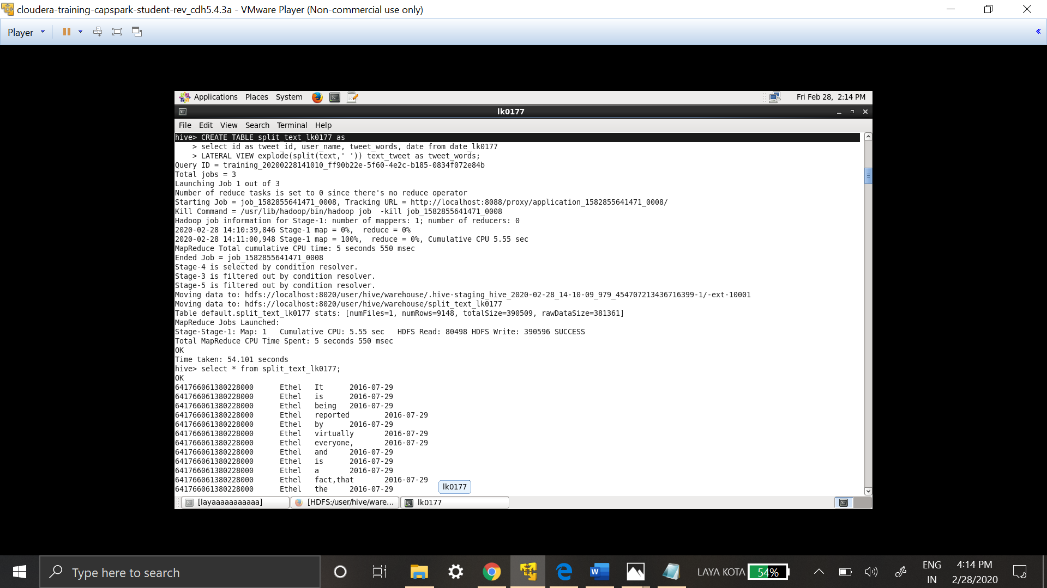

**Join between split_text table and dictionary table:**

CREATE TABLE join_tweet_dict_lk0177 as

select st.tweet_id, st.user_name, st.date, st.tweet_words, d.rating

FROM split_text_lk0177 st LEFT OUTER JOIN dictionary_lk0177 d on (st.tweet_words = d.word);

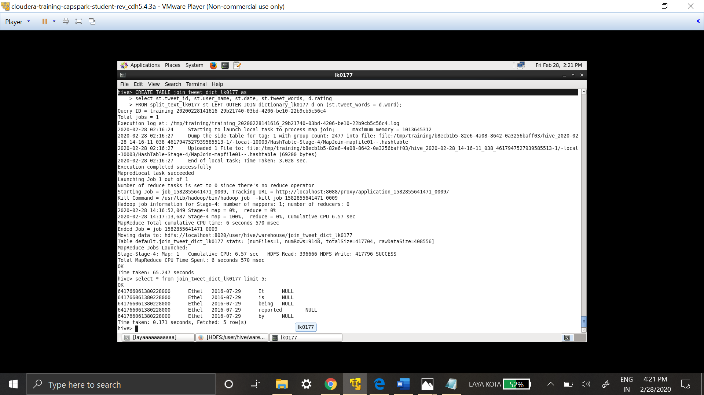

**Creation of table that has score – over all rating and providing sentiment analysis results:**

CREATE TABLE score_lk0177 as

select tweet_id, user_name, date, sum(rating) as score

FROM join_tweet_dict_lk0177

GROUP BY tweet_id, user_name, date;

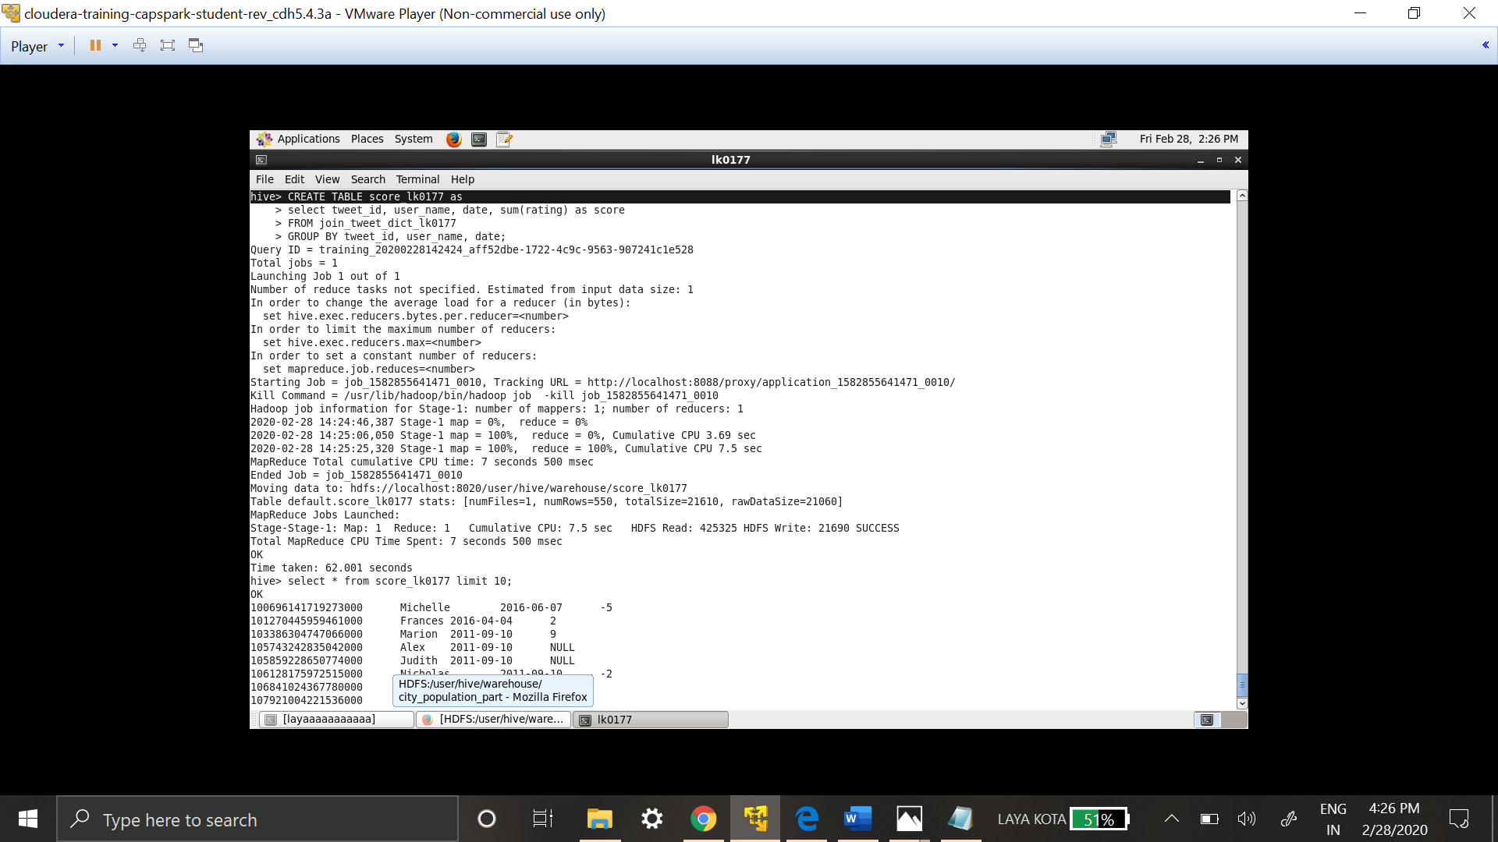

Score table has all the sum of ratings of tweet data.

CREATE table sentiment_analysis_lk0177 as

SELECT tweet_id, user_name, date, score,

CASE WHEN score > 0 THEN 'Positive'

WHEN score < 0 THEN 'Negative'

ELSE 'Neutral'

END as tweets_sentiment_analysis FROM score_lk0177;

Sentiment analysis table is created which results as positive if the sum of rating is more than 0, negative if sum is less than 0 and neutral if sum is 0. The following query is used to validate table.

Select * from sentiment_analysis_lk0177;

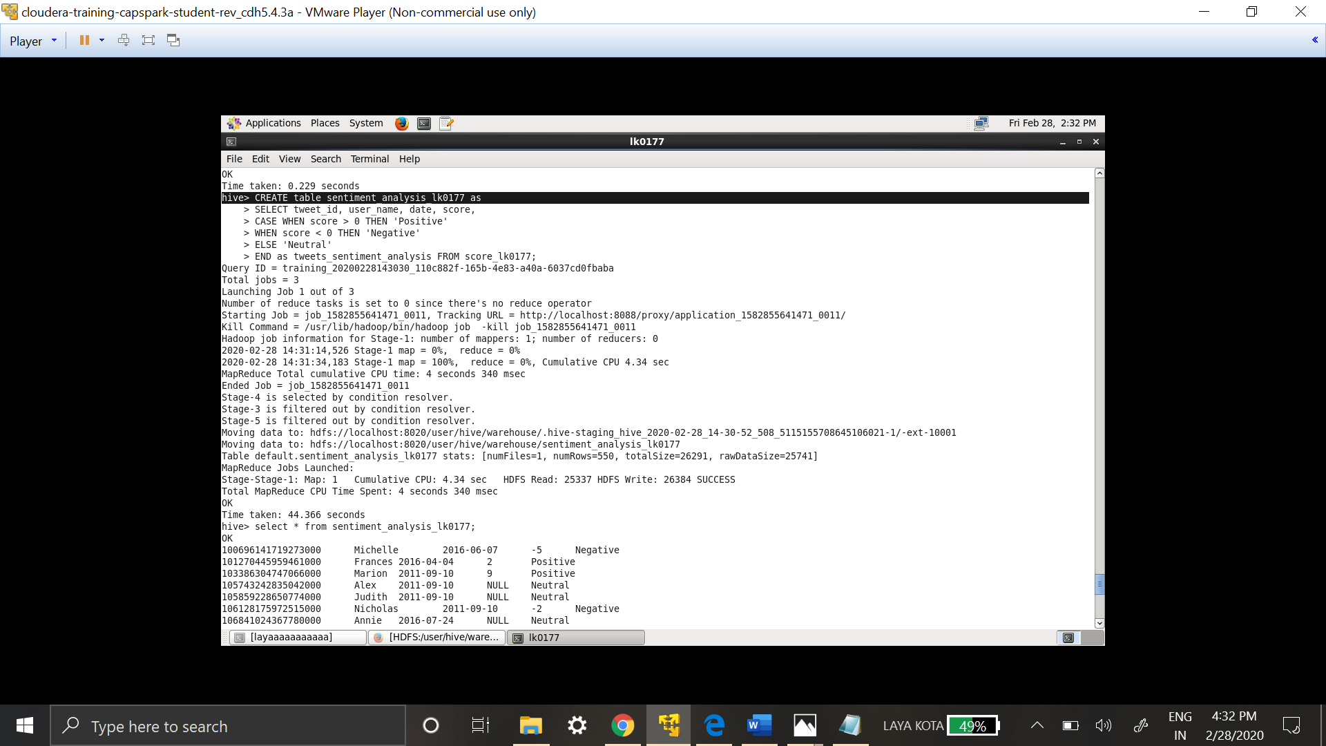

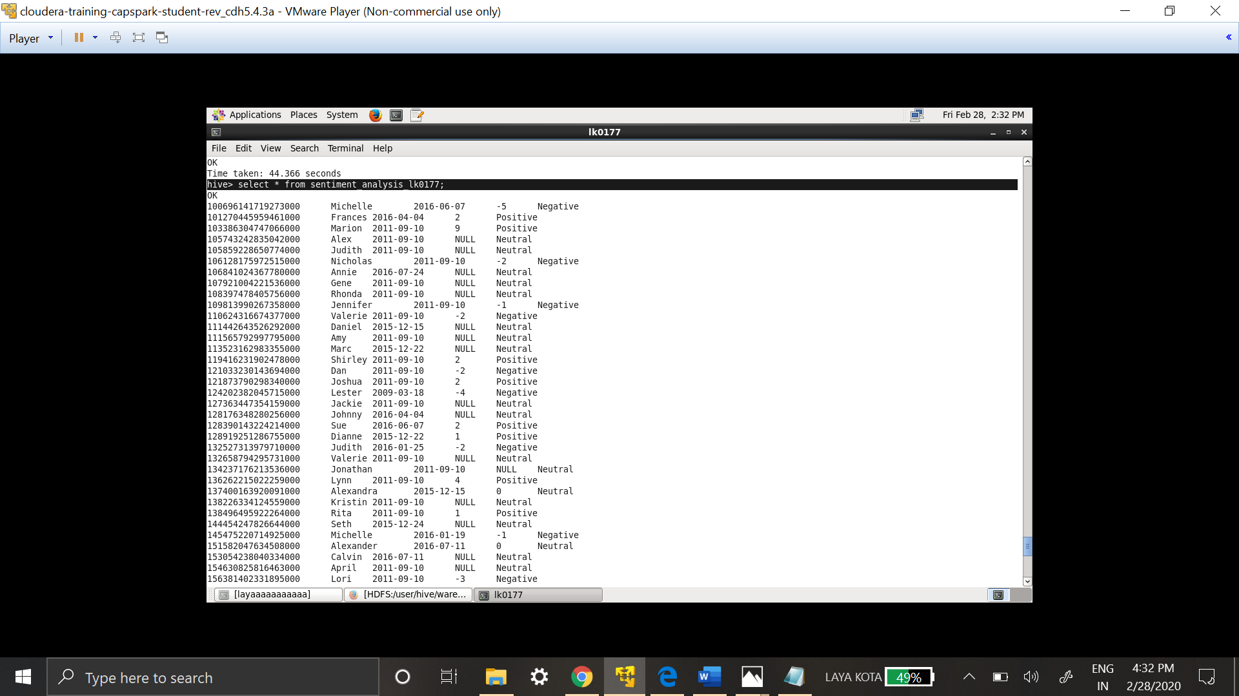

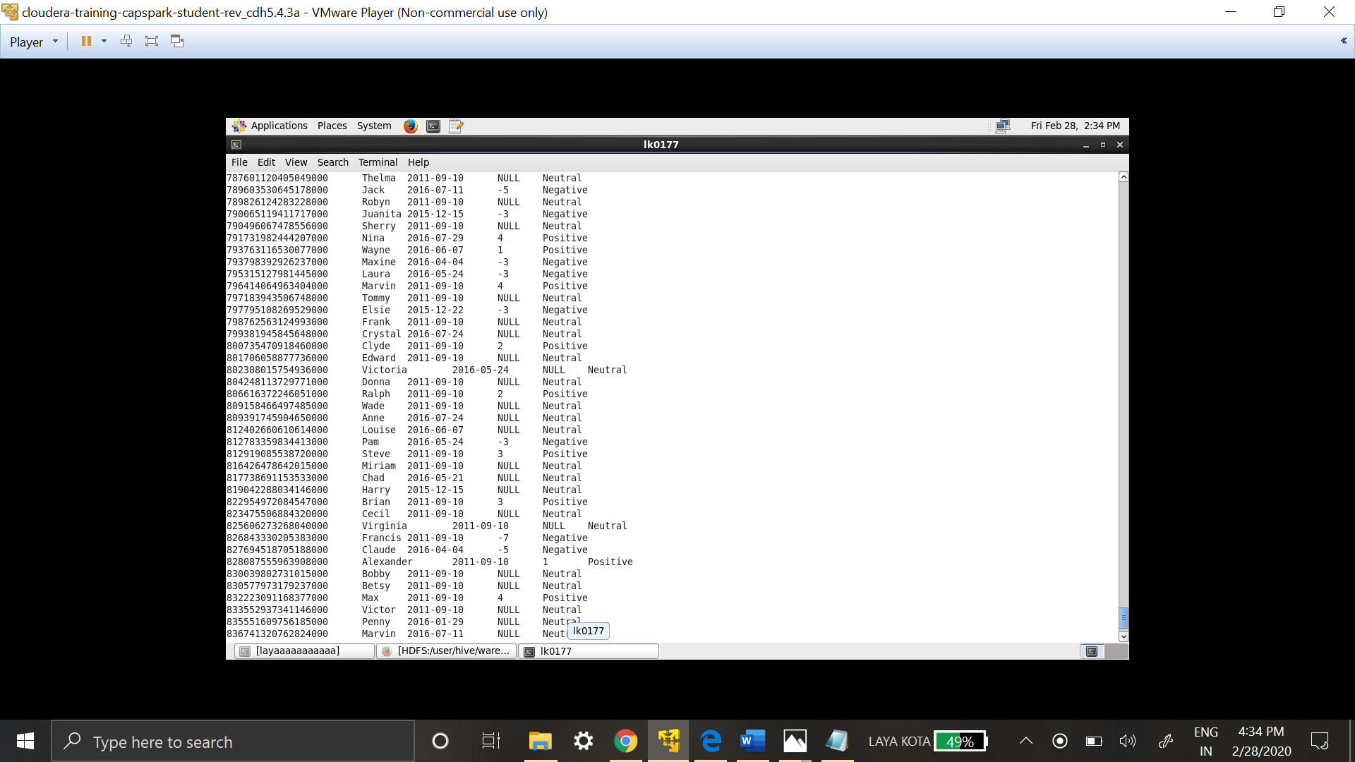

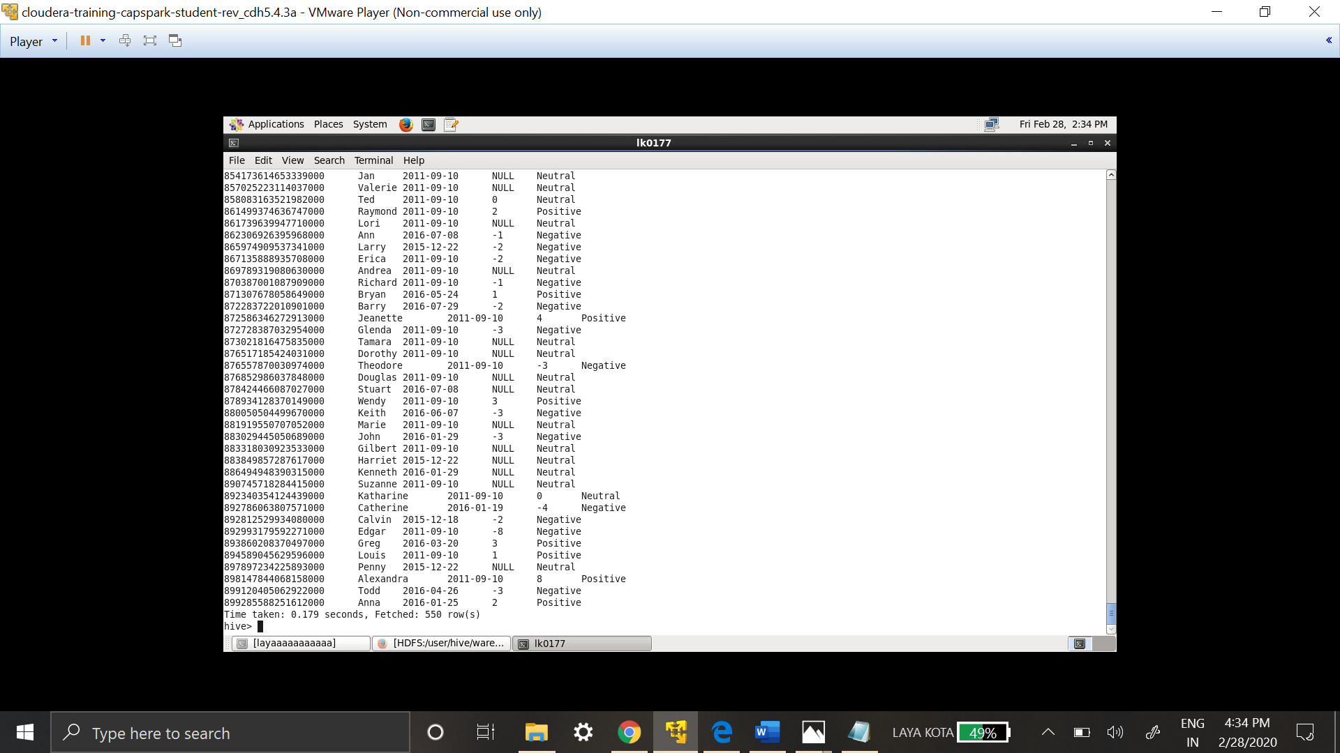

**3. Propose a better solution for the sentiment analysis as compared to 1(c). Cite the source. (5 points) Note: You just need to provide the solution, you are not required to solve the problem using the solution.**

Many advance techniques are used these for sentiment analysis like Machine Learning with python using the Natural Language Toolkit (NLTK).

<https://www.analyticsvidhya.com/blog/2018/07/hands-on-sentiment-analysis-dataset-python/>

Many tools that analysis data as it comes on daily bases like monkey learn.

<https://monkeylearn.com/blog/sentiment-analysis-of-twitter/>